HOMEWORK
- Draw the shape corresponding to the Boolean expression
a, (x > 2 and x < 4) or (y < 2) 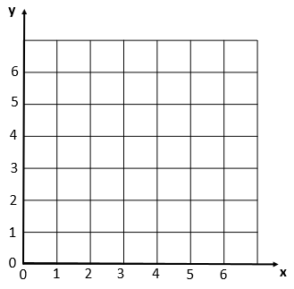

b, (x>2 and x<6) and (y>2 and y<6) and not(x>4)

2, Write the boolean condition for this grid
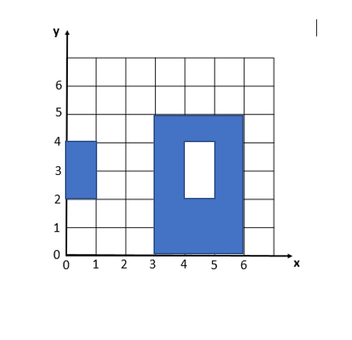

2. Demonstrate these equalities using the 9 simplification rules you have learnt:
- !(C and D) and (!C or D) and (C or !D) = !C
!(C and D) and (!C or D) and (C or !D) = !C or !D and (!C or D) and (C or !D)
= (!C or !D) and (!C or D) and (C or !D)
= !C or (!D and D) and (C or !D)
= !C or False and (C or !D)
= !C or (False and C) or (False and !D)
= !C or False or False
= !C

- ! ( !C and (!B or !C) ) = C
! ( !C and (!B or !C) ) = !( ( !C and !B ) or ( !C and !C)
=!( (!C and !B) or !(C or C)
= !( !C and !B) or !C
=!(!C and (!C or True))
=!( !C and !C)
= !(!C
=C

- (A and B) or (A and !B) = A
(A and B) or (A and !B) = A and (B or True)
= A and True
= A

3.. What is the output of flowchart? If x=6 and y = 5 and z = 1
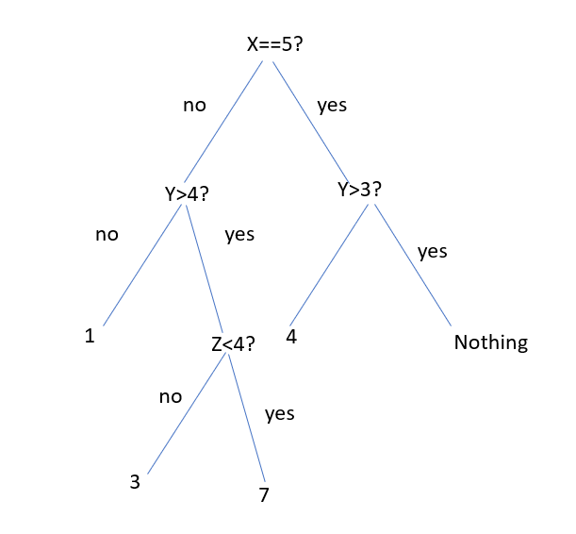
So (If x=6 and y = 5 and z = 1) = 7

- Draw the tree of conditions
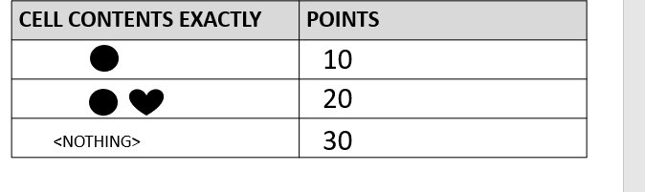

20

10
30

- Draw the tree of conditions

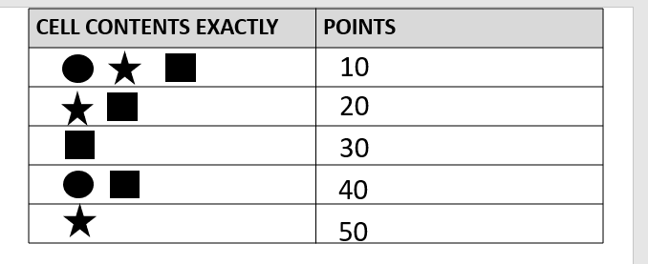

30
10
20

50

40

- Draw the tree of conditions

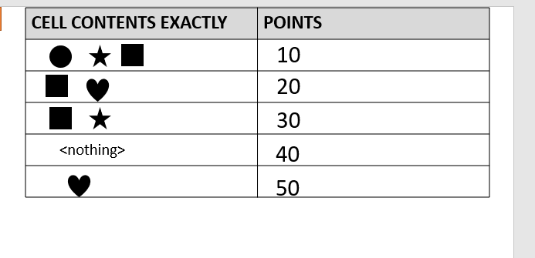

50

10
20

30
40
7.
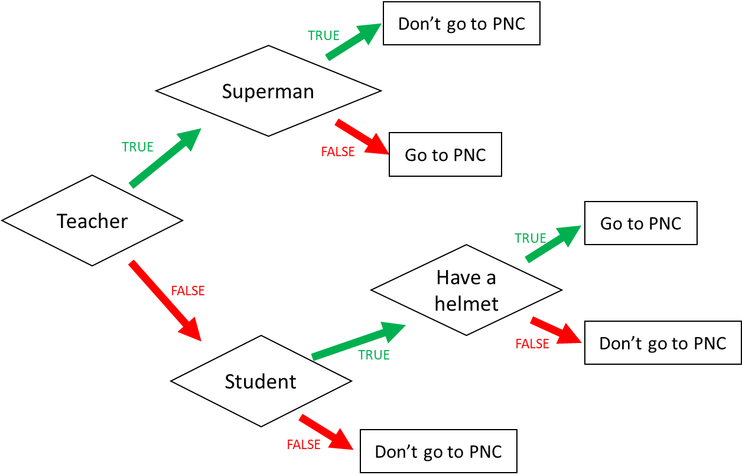

- I am a teacher and I am superman, can I go to PNC?
Answer: no
- I am not a teacher and not a student, can I go to PNC?
Answer: no
- When can I go to PNC? (Express the condition using a Boolean expression)

I go to PNC if:
I am a Teacher and I am not superman or I am
not Teacher and I am student and have a helmet

8
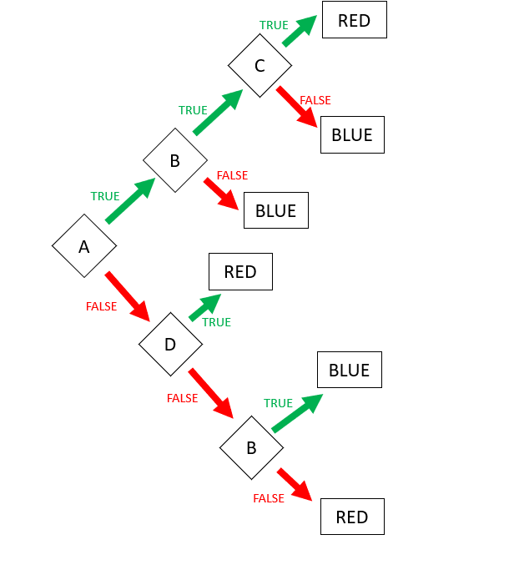

Expression: RED = ABC or !AD or !A!D!B

Expression: BLUE (FALSE) =!A!D!B

9. Encoding
- First 3 characters “MIX”, repeated many times (max repetition is 5)
- Then 1 character “!”, repeated many times (max repetition is 5)
- Then 1 number (0-3)

Examples:

MIXMIXMIX!1
MIX!!!!!3
MIXMIXMIX!!!2

Q1. Propose an encoding structure to encode this image.
Encoding parts | Encoding values (in binary)
The repetition of text “MIX”: 1…5 | 001…101
The repetition of character “!”: 1…5 | 001…101
The number of the end: 0..3 | 00…11

Q2. What is the total size of your encoding? Give explanations.

Encoding size:8bits
Explanation:
Part1: 101 that mean text of MIX repeated 5 times
Part2: 101 that mean character if ! reqpeated 5 times
Part3: 11 that mean the number at the end is 3.
We want to encode a text following those rules:
- 3 letters: A, B, C
- The letters are always in the alphabetic order
- Letters are repeated from 1 to 10 times
  - Each letter is repeated the same number of times
- The last character must be either: X, Y, or Z

Examples:
ABCZ | Good
AAAABBBBCCCCX | Good
AABBCCY | Good
AAABBBCCCX | Good
AABBBBCCX | Bad: letter A is repeated 2 times but letter B 3 times

Q1. Propose an encoding structure to encode this image. (20pts)
Encoding parts | Encoding values (in binary)
The repetition of text “ABC”1….10 | 0001…1010
The repetition of text  - X  - Y  - Z | 00..00  00…01  00…10

Q2. What is the total size of your encoding? Give explanations.
Encoding size:(4pts)
10 Bits
Explanation:(6pts)
Part1: 1010 that mean text of ABC repeated 10 times
Part2: 00,01,10 that mean the number at the end is 3

